Ubotica Delivers Increased Edge Compute Performance per Watt for In-Orbit AI

Dublin, Ireland: 22 February 2023, Ubotica Technologies, the leading provider of smarts for smart satellites, today announced CogniSAT-XE2 the next generation hardware platform for delivering state of the art Artificial Intelligence (AI) in space.

Building on the flight proven CogniSAT technology, CogniSAT-XE2 comes in a mechanical and power envelope compatible with small satellites even down to CubeSats and delivers increased compute performance per Watt.

Satellites designed using CogniSAT-XE2 accelerate system return on investment by maximising in-orbit data analysis capabilities to deliver actionable insights in real-time and optimising downlink data load. CogniSAT-XE2 provides the AI capabilities to enable a wide variety of AI-enabled applications such as real-time navigation and collision avoidance assistance, image analysis and insight generation, area of interest identification and smart data management.

According to John Doody, VP Product at Ubotica, “CogniSAT-XE2 expands the capabilities and autonomy of Earth Observation satellite constellations. Image analysis at the edge in space can be used to direct space-based observation assets in real time to areas of specific interest. Operation of CogniSAT-XE2 is programmable in orbit and can be dynamically enhanced based on operator need or the real-time analysis of sensor data.”

Operators can easily integrate CogniSAT-XE2 within their satellite systems using the CogniSAT-HCS host control software which can also orchestrate the use of the CogniSAT-XE2 platform for many different tasks during a single orbit. The CogniSAT-TK provides the AI software developer with a range of image pre-processing and post-processing algorithms which will speed up the development of applications optimised for the CogniSAT-XE2 platform.

CogniSAT-XE2 is available now and will fly on the Ubotica CogniSAT-6 mission announced in November 2022. [https://ubotica.com/news-release-cognisat-6/]

Ubotica is at the heart of semi-autonomous satellite systems that provide real-time insights from flexible on-board processing and that use affordable, low energy hardware. The Ubotica CogniSAT platform was developed with deep insight of processing hardware, computer vision software and AI system integration. CogniSAT technology has already been proven in multiple space flown projects with partners in Europe and the USA, including NASA JPL and the European Space Agency (ESA).

In March, Ubotica will exhibit at Paris Space Week and Satellite 2023 in Washington, DC.

-ENDS-

Notes to Editors

About Ubotica

https://ubotica.com/

Press Office: Ubotica@SingletonPR.com

Founded in 2017, Ubotica Technologies provides smarts for smart satellites. Our products and services are used by global space industry partners to deliver real-time insights directly to users.

Ubotica is headquartered in Dublin, Ireland with a team of AI Engineers based in DCU Alpha, and has a team of Computer Vision Engineers in Spain and Canada, and a team of space systems experts in the Netherlands based in the Aerospace Innovation Hub at the TU Delft Campus.

The founders of the company have deep expertise in the advanced technology sector globally and have developed innovative technology, successfully brought complex products to market and delivered high value exits including Parthus Technologies, GloNav and most recently Movidius.

Image :

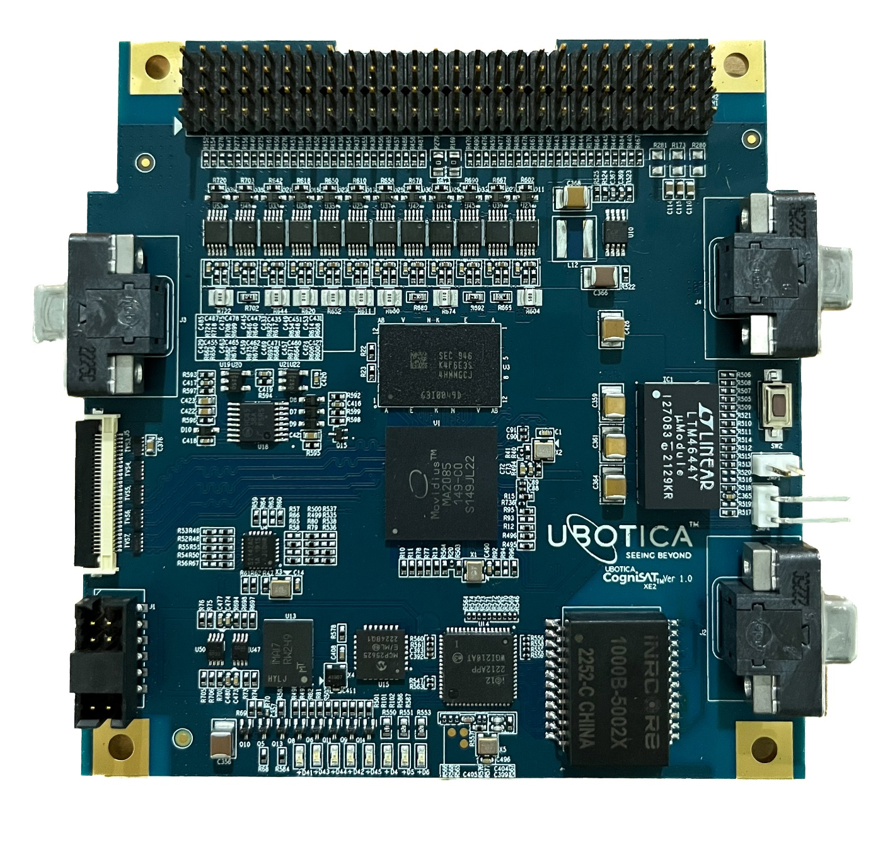

Source: Ubotica Technologies
Released 22 Feb 2023

